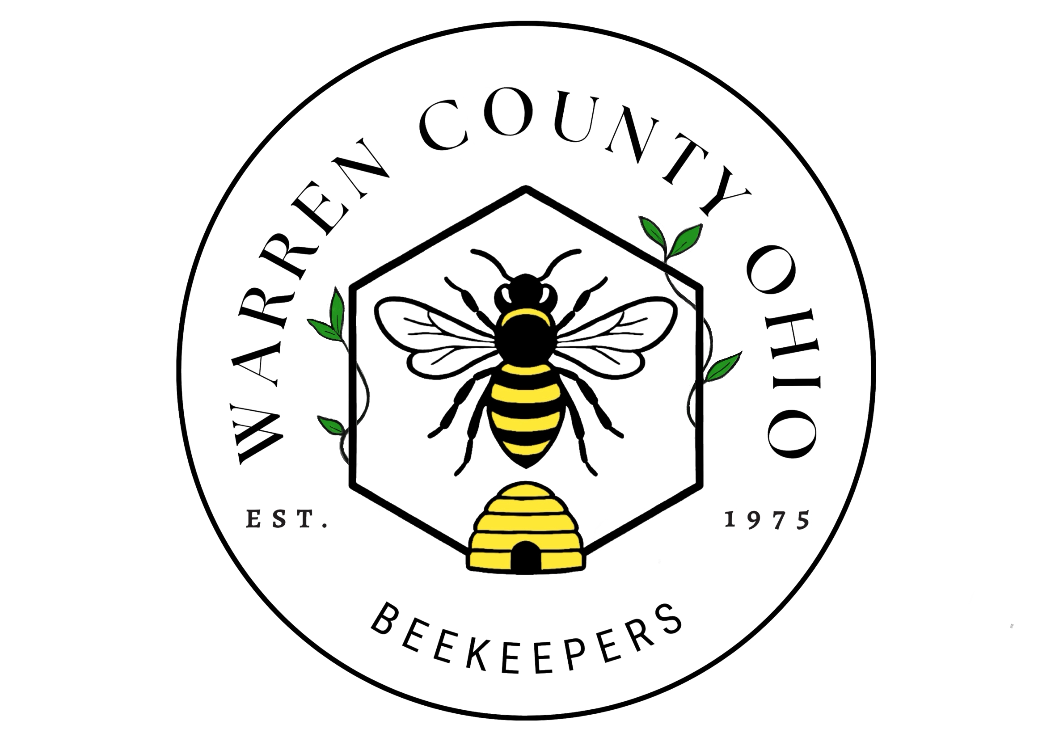
Warren County Beezette
February 2026
February News:
- First Meeting of 2026! Our February meeting will be Monday the 9th at 6:30pm located at 221 S. Forest Ave. Mason, Ohio. This month’s meeting will cover setting up personal apiaries an we will be discussing setting up our Club Apiary!

January Recap:
- Thanks to everyone who came out to our Bee School! It was an absolutely incredible day of speakers, vendors, and education. We want to give a special thanks to our community for coming out and making this our LARGEST Bee School to date!
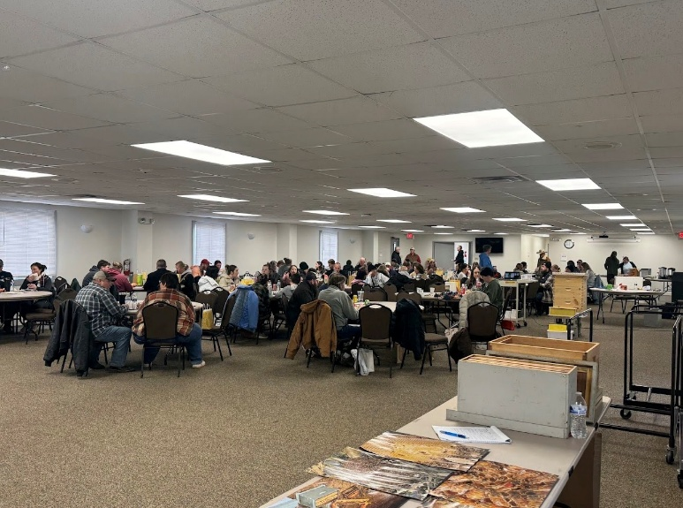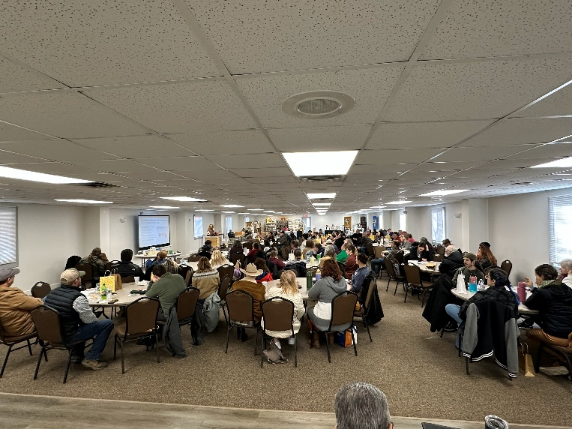

What to do this month:
- On a day over 50 degrees do a quick check on hive- 30 seconds or less
- Check your hive’s food supply and add food if needed
- Ensure mouse guard is in place.
- Consider Varroa treatment with OA vaporization.
- Time to research your books and continue to be observant. Check previous lists to confirm you are ready for the coming year.

2026 Calendar at a Glance
January 24 | Bee School  Armco Park: Jones Pavillion
February 9 | Apiary Prep and Club Apiary Intro  Sacred Mission Church
March 9 | Swarms & Club Sign-Up Swarmed  Sacred Mission Church
April 13 | Bees the Pollinators/ Pro Garden Tips  Sacred Mission Church
May 11 | Hive Management  Sacred Mission Church
June TBA | On Site Club Apiary: Special Presentation from our hosts from Cincinnati Zoo  Bowyer Farm
July 20-24 | Warren County Fair!  Lebanon
August 10 | Pest Control  Sacred Mission Church
September 14 | Club Picnic Featuring Products of the Hive  Golden Valley Bee Barn
October 12 | Hive Winterization  Sacred Mission Church
November 9 | Holiday Honeybee Market  Golden Valley Bee Barn
December 14 | No Meeting. Merry Christmas!

